Khaya Nxumalo
CLDV6212 POE Part 1
Web app link - https://st10451478.azurewebsites.net/
Github link - https://github.com/IIEWFL/cldv6212-part-1-st10451478-Khaya-Nxumalo.git

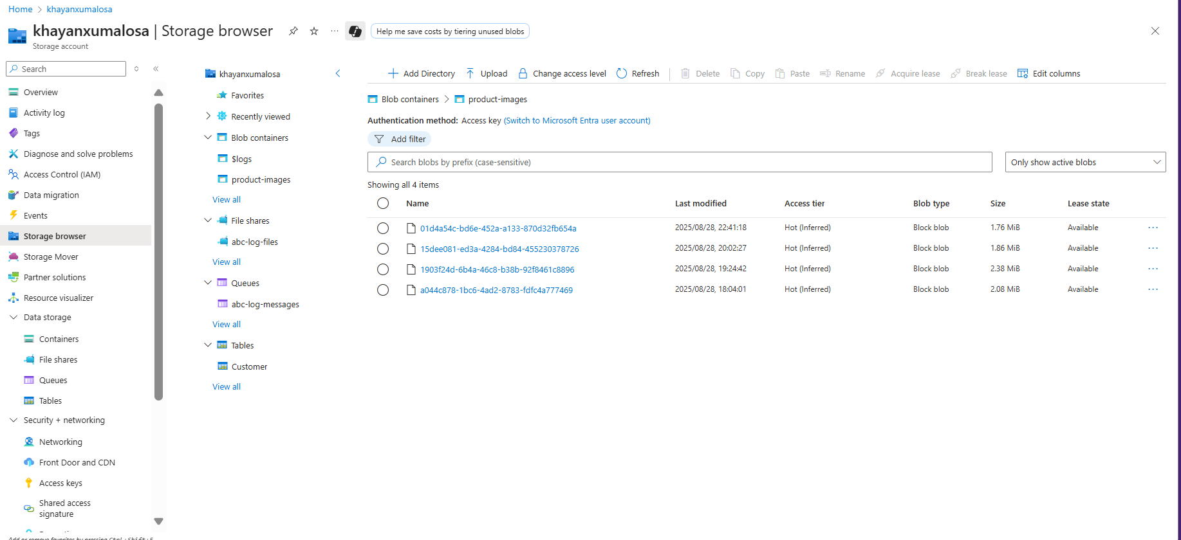
Screenshots
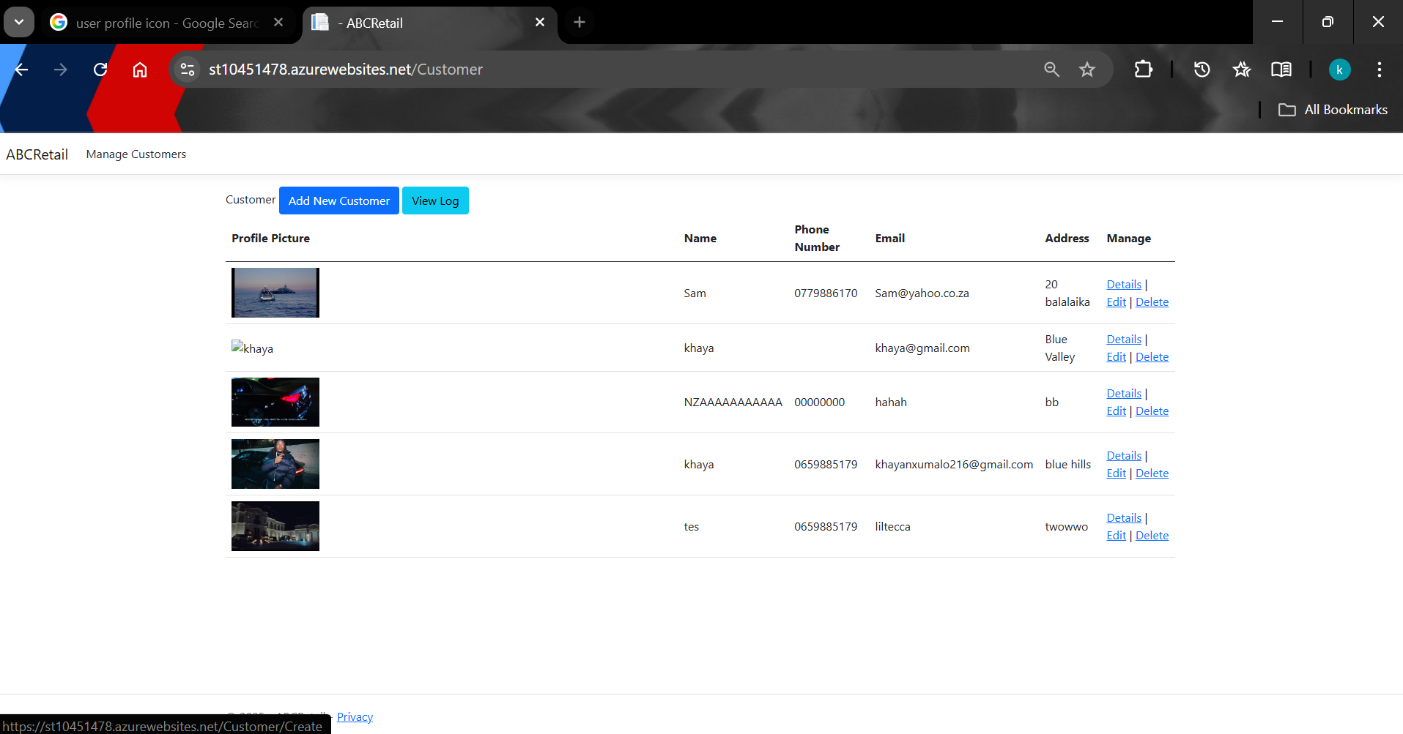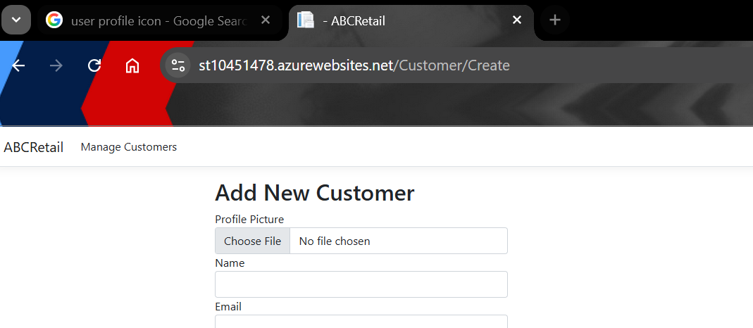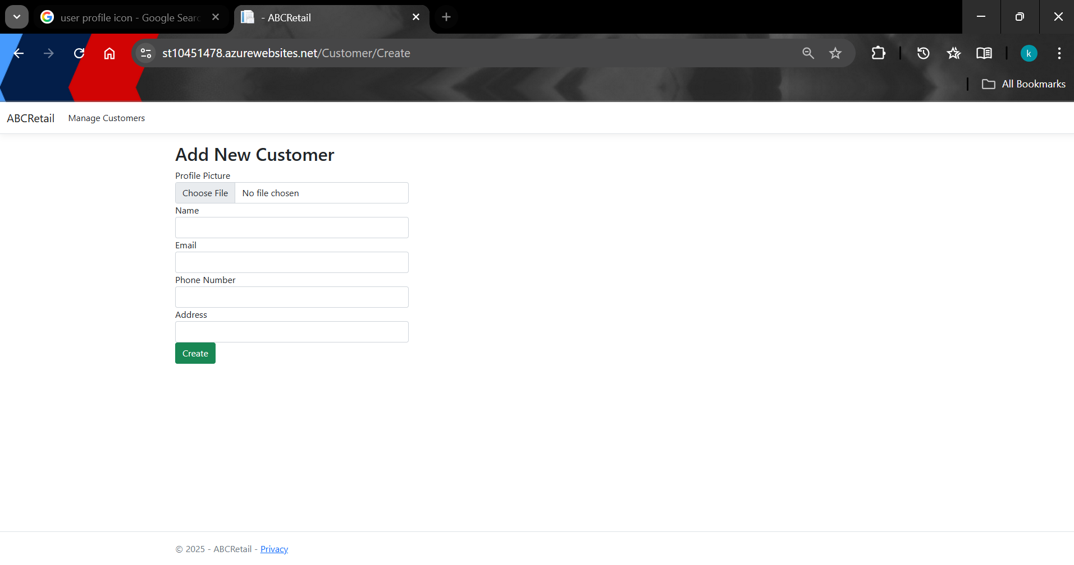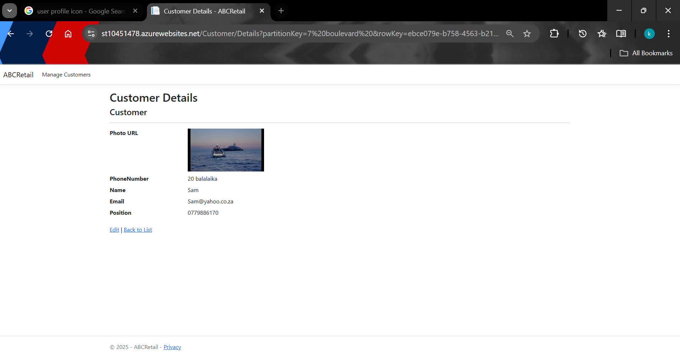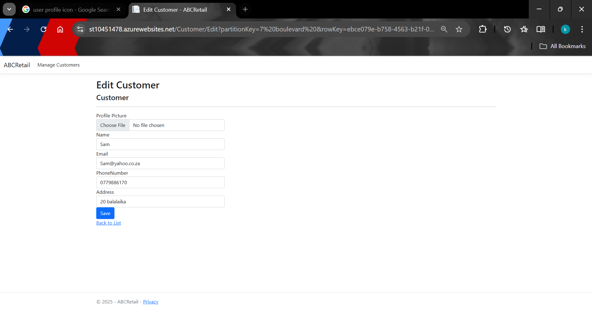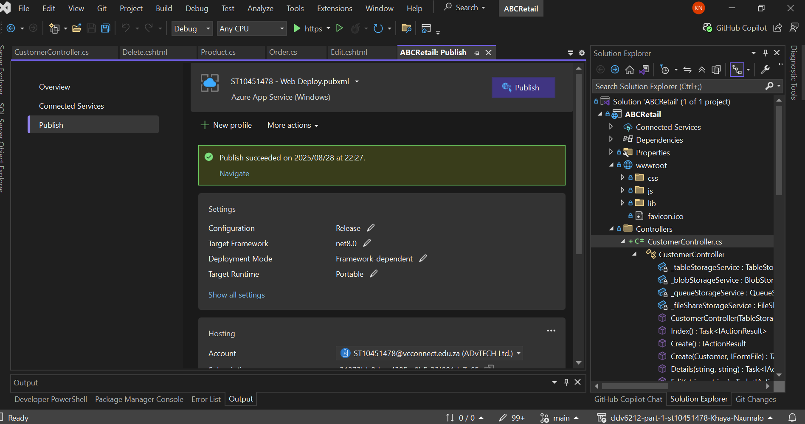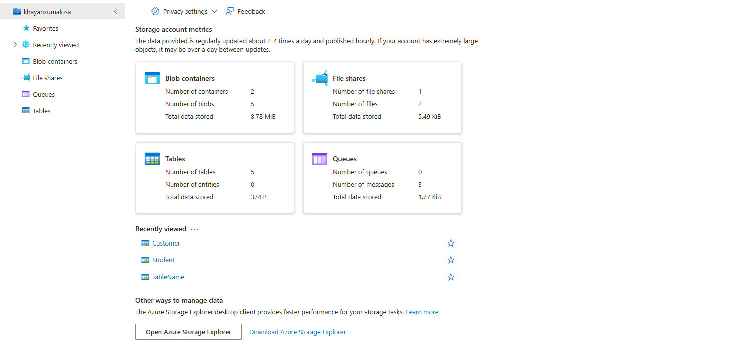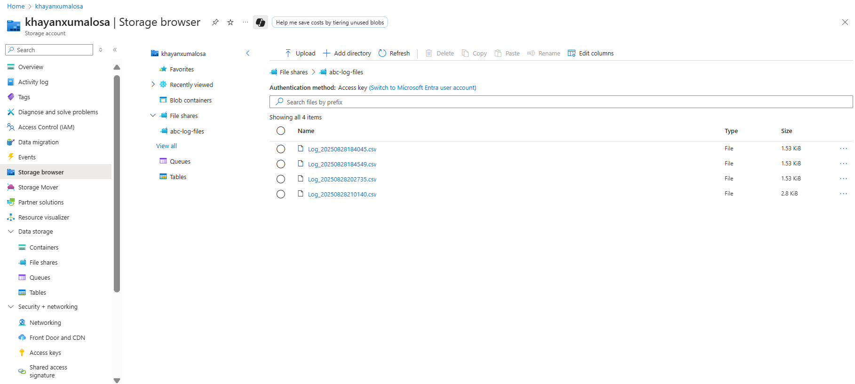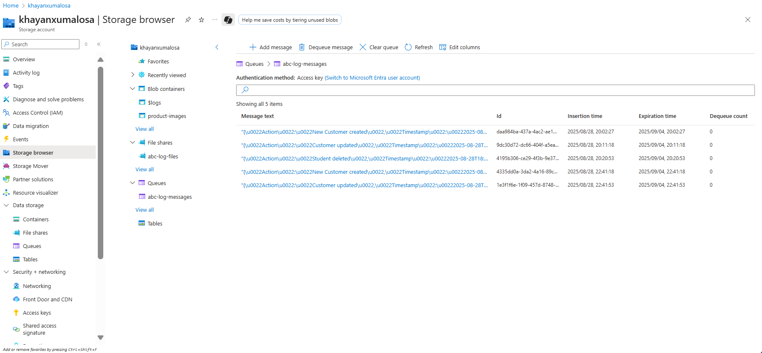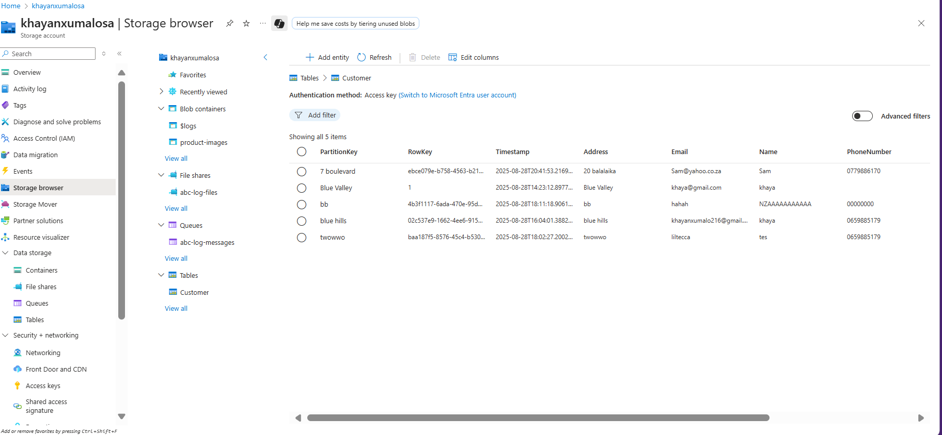

References
Code Maze, 2022. Azure Table Storage with ASP.NET Core. [online] Available at: https://code-maze.com/azure-table-storage-aspnetcore [Accessed 25 Aug. 2025].
2.
C# Corner, 2018. Azure Storage CRUD Operations In MVC Using C# - Azure Table Storage - Part One. [online] Available at: https://www.c-sharpcorner.com/article/azure-storage-crud-operations-in-mvc-using-c-sharp-azure-table-storage-part-one [Accessed 25 Aug. 2025].
3.
C# Corner, 2023. Best Practices for Azure Table Storage. [online] Available at: https://www.c-sharpcorner.com/article/best-practices-for-azure-table-storage [Accessed 25 Aug. 2025].
4.
Microsoft Learn, 2024. Azure Tables samples for .NET - Code Samples. [online] Available at: https://learn.microsoft.com/en-us/samples/azure/azure-sdk-for-net/azure-tables-client-sdk-samples [Accessed 25 Aug. 2025].
5.
Microsoft Learn, 2024. Performance and scalability checklist for Table storage. [online] Available at: https://learn.microsoft.com/en-us/azure/storage/tables/storage-performance-checklist [Accessed 25 Aug. 2025].
6.
Microsoft Learn, 2024. Azure.Data.Tables Namespace - Azure for .NET Developers. [online] Available at: https://learn.microsoft.com/en-us/dotnet/api/azure.data.tables [Accessed 25 Aug. 2025].

